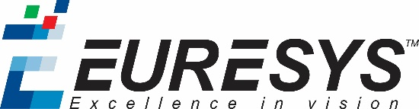

Euresys General Commitment

Dear Valued Customer,
EURESYS develops products based on electronic circuit boards. We have chosen a subcontracted production process. Nevertheless, Euresys is submitted to RoHS and REACH standards requirements as well as to all the regulations relating to poisonous and/or recyclable substances.
In this context, Euresys does its best efforts to make sure that its products are compliant and i.e.:
- We require our suppliers to purchase their components only from manufacturers who comply with the above listed regulations.
- We make all RoHS, REACH and conflict minerals certificates available on request to any concerned person.
- We choose our subcontractors accordingly and require them to purchase from accordingly elected manufacturers and components.
- We strives to designate doubt free components only to be assembled in our products and to exclude every illegal component.
- We empower all employees, suppliers, vendors and contractors to take ownership in complying with the European Union regulations in terms of dangerous substances and recycling recommendations and to escalate risks in the supply chain to management's attention.
- We effectively communicate to all employees the necessary points of attention.

Marc Damhaut Claude LATIN
CEO CFO

